**Nelson Foster**

**DATS 6401-11: Visualization of Complex Data**

**Home Project: Fall 2017**

**Overview**

For my final project, I researched datasets from [Data.gov](https://www.data.gov/). Specifically, I focused on datasets from the [Department of Education’s Campus Safety & Security (CSS)](https://ope.ed.gov/campussafety/#/datafile/list). The files I chose (Crime 2016) is a collection of data on various incidents and offences that happened on college campuses of various types from 2013 to 2015.

**Database Creation**

To practice recently acquired skills on the database Extract, Transform & Load (ETL) process,I created an initial database using MySQL and Talend Data Integration Studio:

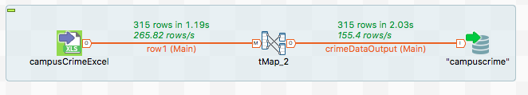

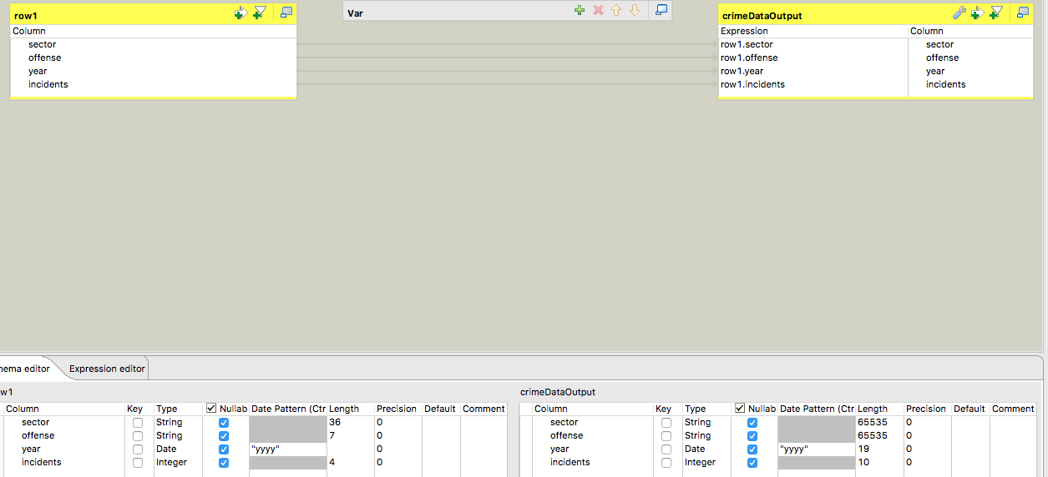

**Test Query to verify data import:**

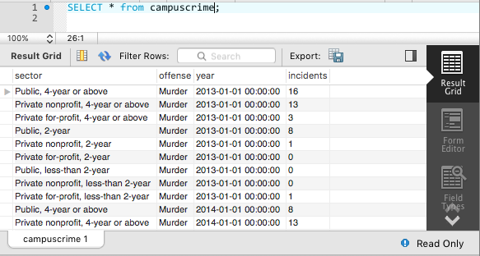

Added additional data via MySQL workbench’s Data Import Wizard and exported into a .sql File.

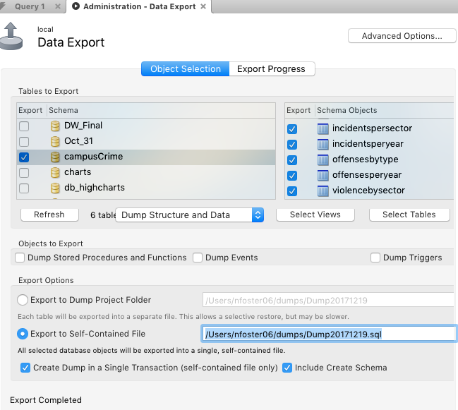

**Visualizations**

***D3:***

The first D3 Visualization I did was a column chart of the number of incidents by Offense type:

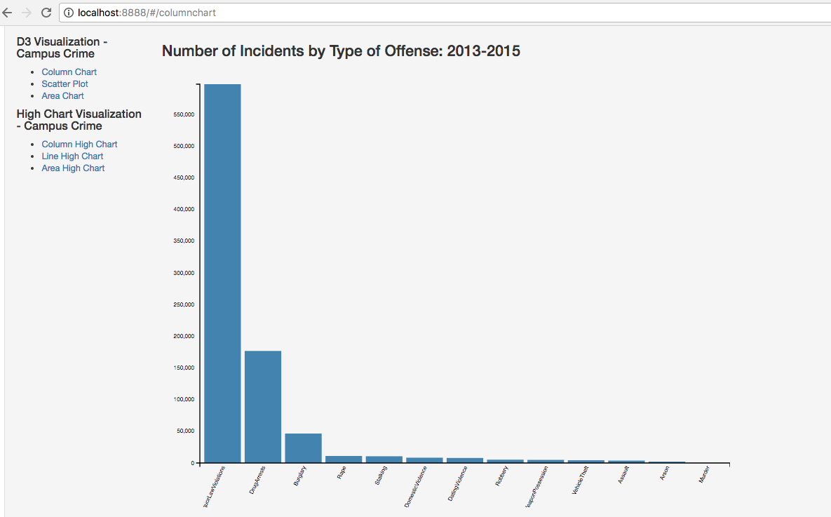

The second D3 visualization I did was a scatterplot to determine the relationship between incidents of assaults and possession of a deadly weapon per “Sector,” such as Private, For Profit, Public, 2-year, 4-year, etc.

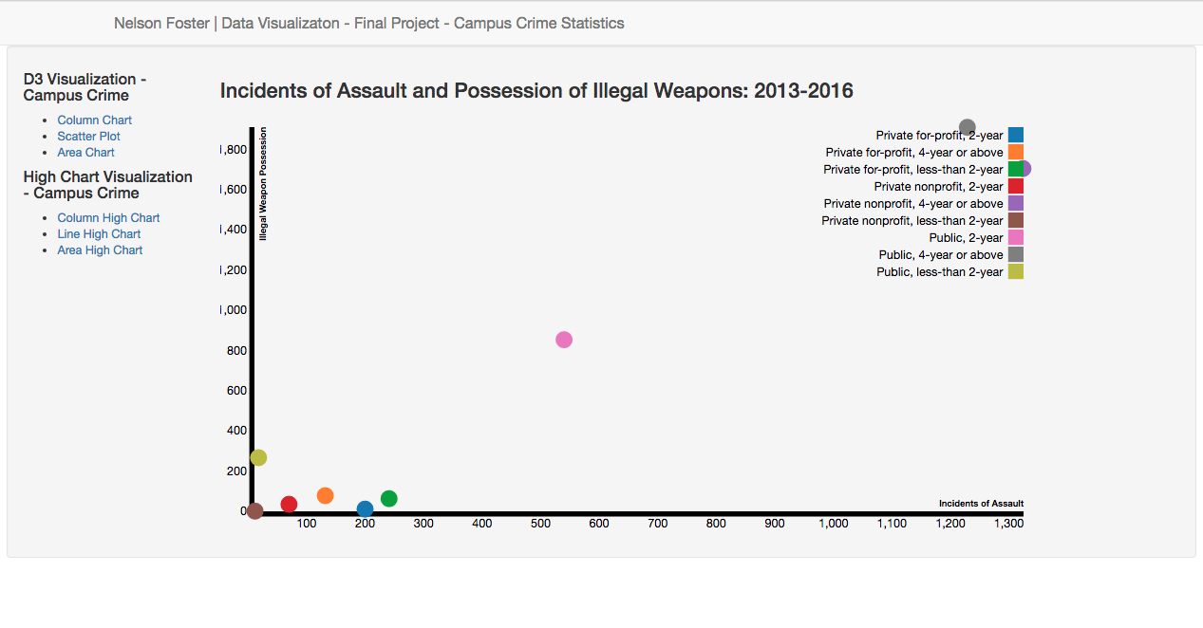

The third D3 Visualization I did was an Area Chart on total crime incidents from 2013-2015

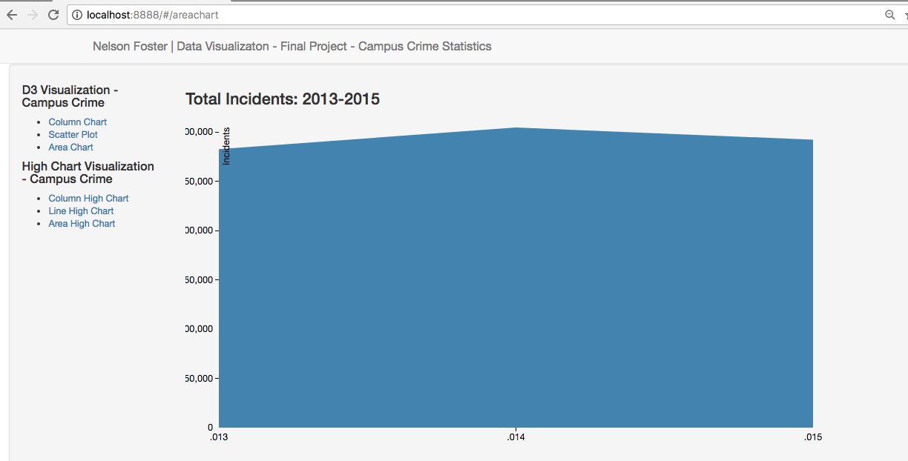

**Highcharts**

**The first highchart I did was a column chart on the number of campus incidents by type:** 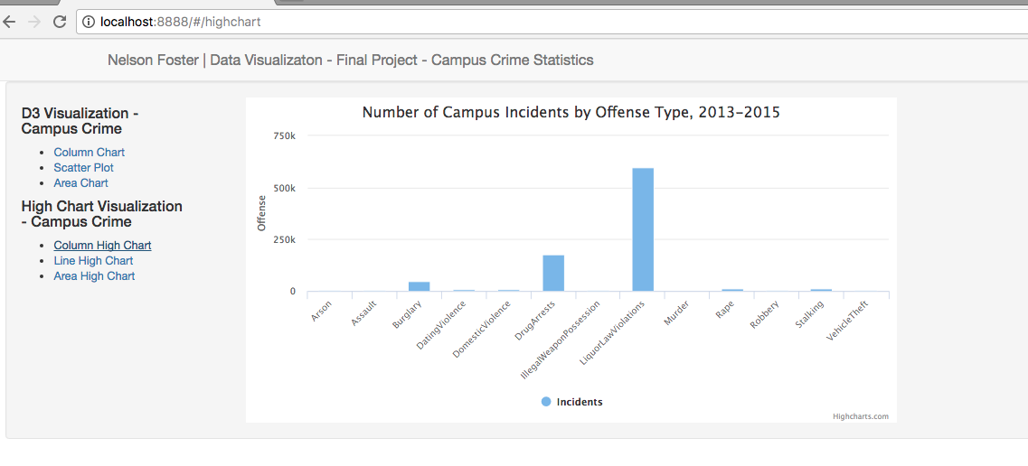

**The second highchart I did was line chart on the number of incidents between 2013 and 2015:** 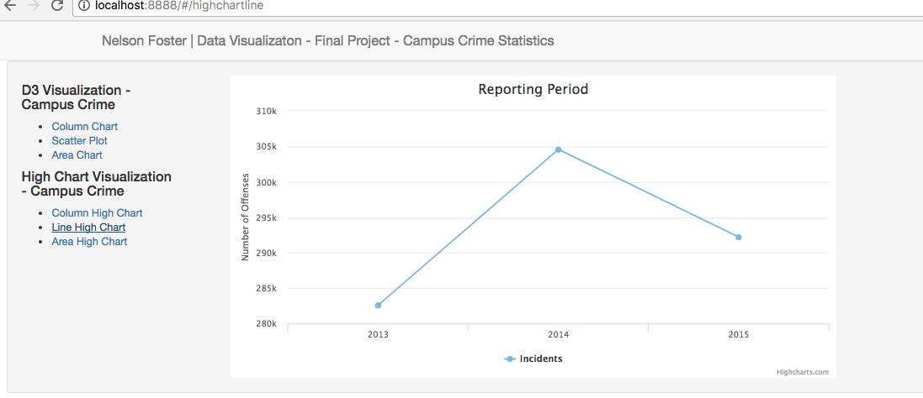

**The third highchart I did was an area chart on total incidents:**

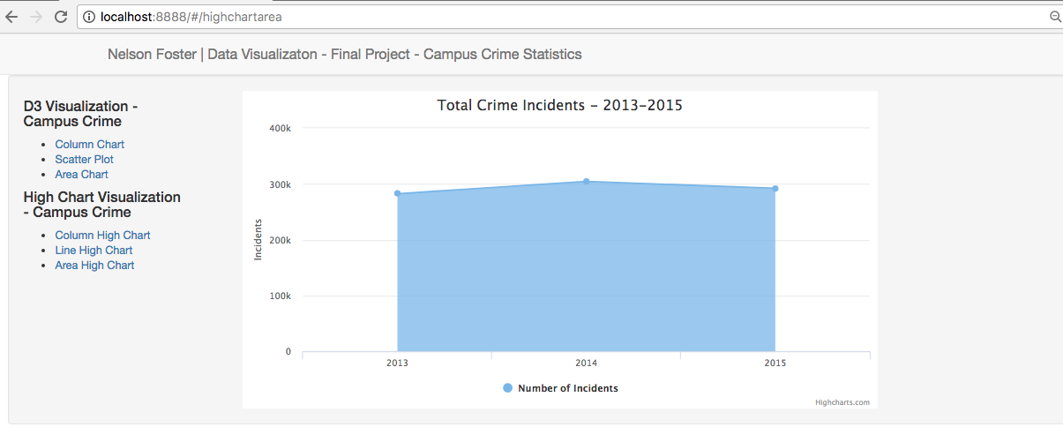

Thank you for a wonderful semester!

References/Research

<https://ope.ed.gov/campussafety/#/datafile/list>